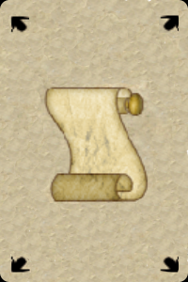  INITIATE  INITIATE | STUDENT  STUDENT | PRENTICE  PRENTICE
JOURNEYMAN  JOURNEYMAN | SCRIBE  SCRIBE | MASTER  MASTER
  INITIATE  INITIATE | STUDENT  STUDENT | PRENTICE  PRENTICE
JOURNEYMAN  JOURNEYMAN | SCRIBE  SCRIBE | MASTER  MASTER
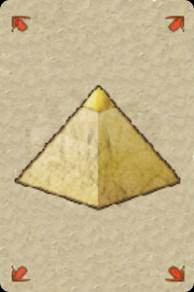  INITIATE  INITIATE | STUDENT  STUDENT | PRENTICE  PRENTICE
JOURNEYMAN  JOURNEYMAN | SCRIBE  SCRIBE | MASTER  MASTER
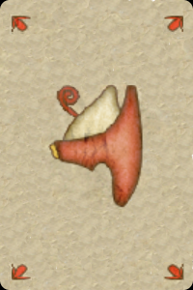  INITIATE  INITIATE | STUDENT  STUDENT | PRENTICE  PRENTICE
JOURNEYMAN  JOURNEYMAN | SCRIBE  SCRIBE | MASTER  MASTER


